## PRINCIPLES OF SOFTWARE ENGINEERING

## COURSE CODE: SWE1003

## Online Shopping Store

## 

### NAMES REG.NUMBERS

### 

### 1. AMIT KUMAR SAHU 18MIS7250

### 2.CHANDRAMOULI 18MIS7284

### 3. M. RUHI ROSHANARA 18MIS7154

### 4. PAPUGANI VARSHINI 18MIS7035

### 

### 

### 

### 

**INDEX**

|  |  |  |
| --- | --- | --- |
| **Sr. No** | **Title** | **Page No** |
| 1 | Abstract (Project Profile) | 1 |
| 2 | Existing System | 2 |
| 3 | Need for new System | 3 |
| 4 | Functional Specification | 4 |
| 5 | Hardware and Software Requirement | 7 |
| 6 | System Flow Chart | 9 |
| 7 | Timeline Chart | 10 |
| 8 | E-R Diagram | 11 |
| 9 | UML Diagrams | 12 |
|  | 9.1 Use Case Diagram | 13 |
|  | 9.2 Activity Diagram | 15 |
|  | 9.3 Class Diagram | 17 |
|  | 9.4 Sequence Diagram | 18 |
|  | 9.5 Collaboration Diagram | 20 |
|  | 9.6 Deployment Diagram | 22 |

|  |  |  |
| --- | --- | --- |
| **Sr. No** | **Title** | **Page No** |
| 11 | Input Design | 30 |
| 12 | Output Design | 62 |
| 13 | Testing | 65 |
| 14 | Post Implementation Review | 68 |
| 15 | Future Enhancement | 69 |
| 16 | Bibliography | 70 |



|  |  |
| --- | --- |
| **Project Name** | Online Shopping System |
| **Objective** | It is a system design specially for small shopping business  The shopping system provides complete functionality of listing and purchasing clothes.  To take feedback from the user and changing the functions according to the requirement. |
| **Platform** | Application |
| **Front End** | JAVA |
| **Other Tools** | MS Office 2007 , MS Power Point, MS Office Word |
| **Project Duration** | 90days |

* An existing system can provide manually paper work like various receipts while visiting stores .
* The user has to go in the shop where user can get the apparels of their choice and purchase it by just clicking on the application.
* In the existing system you cannot provide feedback of the user to the admin online.
* The new system is totally computerized system.
* A new system provides features like time efficiency to show apparel details, user profiles and whatever the customer will give the feedback to the admin.
* This system provides clothing facilities.
* An inquiry is easily done by user in the system.
* It is the most software application for managing online clothing business.

## USER SPECIFICATION

### Admin :

Admin can add apparels ,brands ,color and cost , and also view feedback and

enquiry.

### User :

User can view information of available apparels, brands ,colors along with displaying their respective costs .The user will receive bill at the end of shopping and can also give feedback.

## MODULE SPECIFICATION

### View Available Apparel :

It is a system design specially for Men’s wear business. The user can view Available Apparel types and user can purchase that.

### View Available Brands with Cost :

The user can view Available brands along with their respective cost and user can selec for that car.

### View Available Colors :

The Customer can easily get the color of the apparel whenever they need to select the color with use of this system.

### Give Feedback :

The customer will give the feedback to the admin.

### Discount coupon code :

The user may have a discount coupon code with the help of this the user can get exclusive discounts.

### Add to Cart :

The user can add more items so that The user can see the available cars and book the car.

### View Feedback :

The admin easily view the feedbacks and solve the query.

### Client side:

|  |  |
| --- | --- |
| **RAM** | Atleast 300Mb |
| **Harddisk** | 10 mb |
| **Processor** | 1.0 GHz |

|  |  |
| --- | --- |
| **Operating System** | Windows or any equivalent OS |

|  |  |
| --- | --- |
| **Framework** | JAVA JDK10 |

**System Flow Chart**

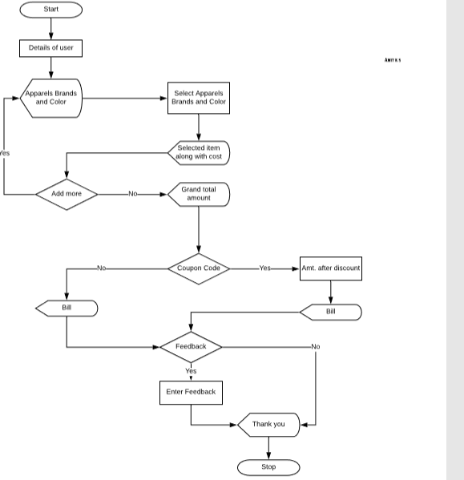

**TIME LINE CHART**

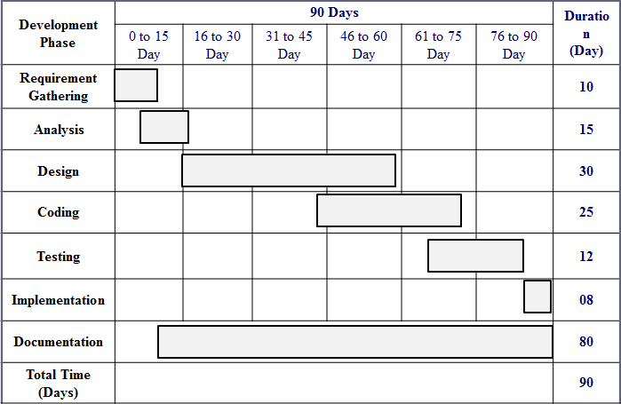

11

# UML DIAGRAMS



USE CASE DIAGRAM 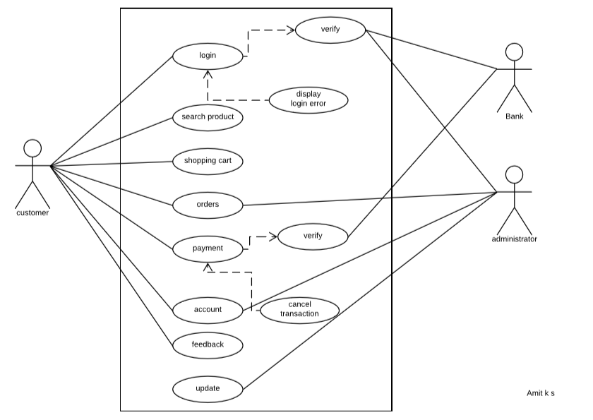

**ACTIVITY DIAGRAM**

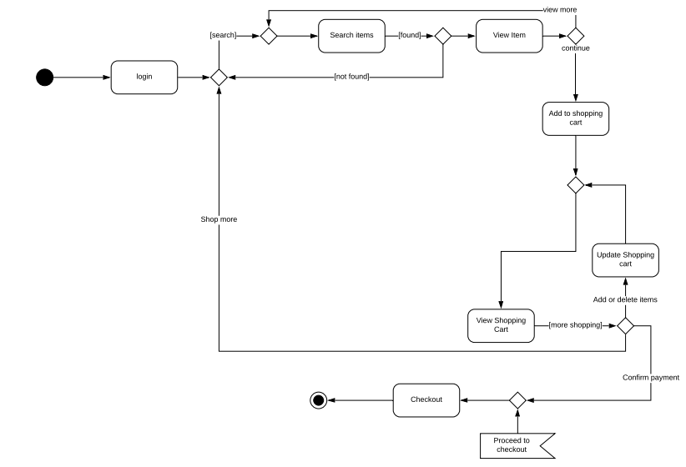

**CLASS DIAGRAM**

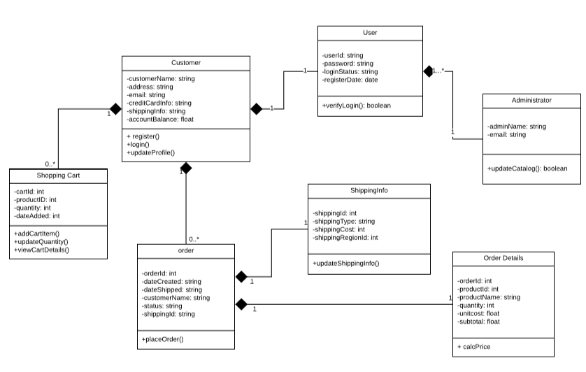



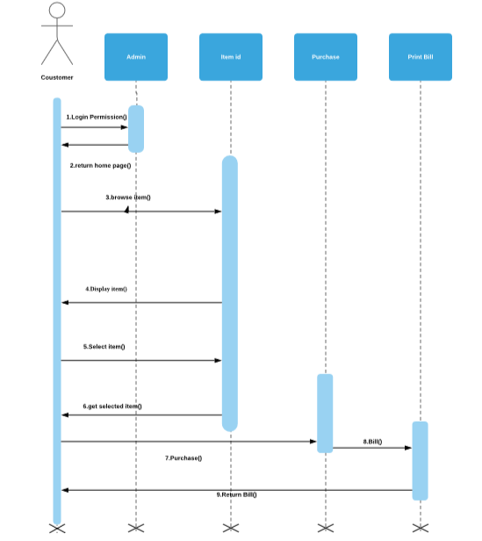 18

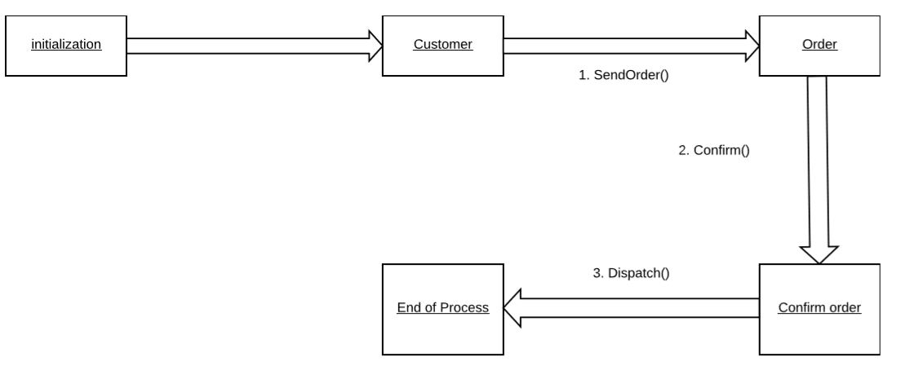

DEPLOYMENT DIAGRAM

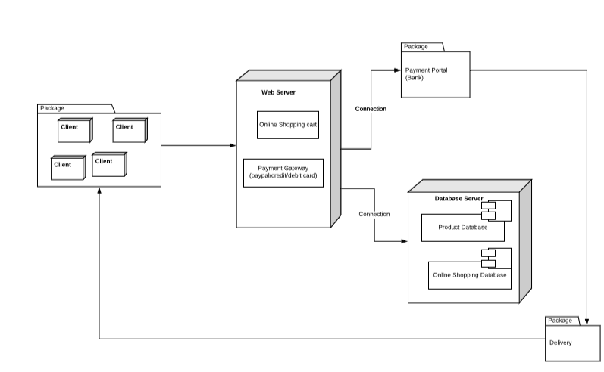

F

SOFTWARE WORKING MODEL

**Java application**

**Enter User details**

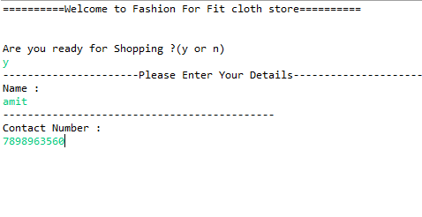

**Display Available apparels**

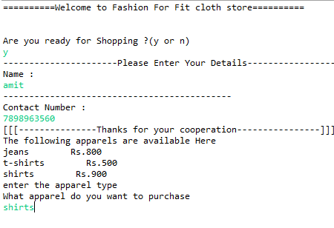

**Display Available brands and colors for apparels along with their price.**

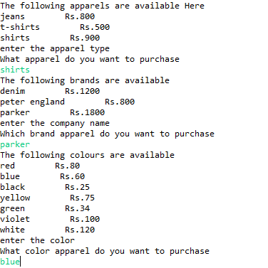

**Items available in cart with total price along with more shopping option!!**

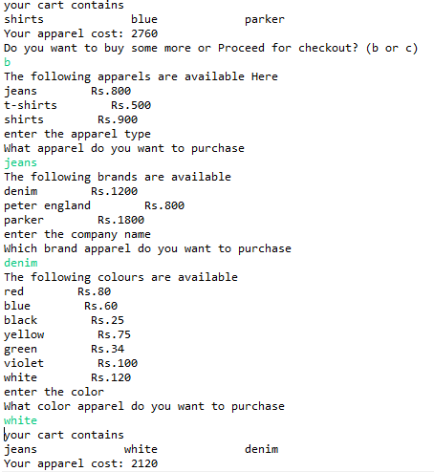



**Discount option for Valid coupon code….**

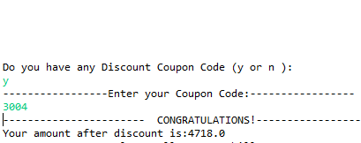

**Invalid coupon code;**

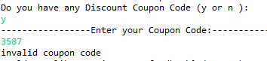

**Bill generation and Feedback:**

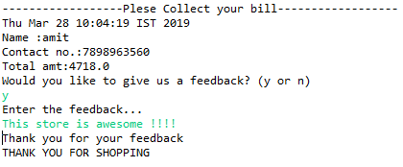

# TESTING

|  |  |  |  |  |
| --- | --- | --- | --- | --- |
| **No** | **Data input** | **Invalid** | **Valid** | **Pass / Fail** |
| 1 | Visit store | Integers and Strings  ~,@,#,$%,^,&,/ | y or n | Pass |
| 2 | Phone No. | Characters and integers | Integers | Pass |
| 3 | Select apparel , brand and color | Integers and characters  ~,@,#,$%,^,&,/ | Selecting strings from given clothes | Pass |
| 4 | Discount | Characters  ~,@,#,$%,^,&,/ | Specified coupon code(integers) | pass |
| The System give an invalid coupon code | Amt after discount | Pass |
| 5 | Buy more or checkout | Characters | b(again displays available items ) | Pass |
| integers  ~,@,#,$%,^,&,/ | c(displays grand total amount and items in cart) | Pass |

* The application is self –maintained.
* The project support already multiple Apparel , brands , costs and color .
* There is no need provide post implementation support.
* The admin can access add ,edit ,delete process and change their products according to the current needs of the people.

* The User payment for the current receipt of the payment and further we can add payment portal .
* Add the current project for purchasing products easily.
* Can add more categories on apparels like women’s wear and kid’s wear and many more.
* Also we can add combo offers for marketing.

### Book Reference:

Pressman Units.

### Web Reference:

* + [www.code-project.com](http://www.code-project.com/)
* www.stackoverflow.com
  + [www.msdn.com](http://www.msdn.com/)